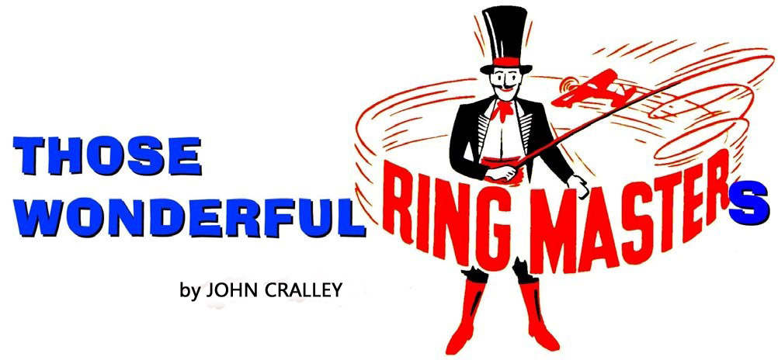
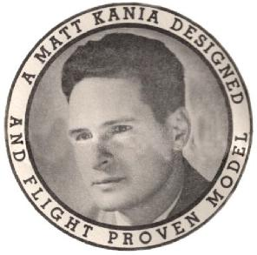
One of the thread titles in the United Kingdom’s Barton Control Line Model forum is: Ringmaster, Every Household should have one! I couldn’t agree more with this sentiment. The Ringmaster S-1 control line model airplane was designed by Matt Kania in 1950 and kitted by Sterling Models Philadelphia, Pa. This 60 year old profile model became the most popular control line model in America. Unfortunately, the Ringmaster is little known throughout the rest of the world. The Ringmaster is a simple, easily built, flapless model that is capable of flying the full stunt pattern of either the US AMA/Pampa or the World FAI organizations. Since this is a flapless model it flies best if built light! S-1 Ringmasters in the 24 to 28 oz. range are highly competitive stunt fliers. It also serves as a good trainer for new pilots, especially the original Sterling S-1 and the newer S-1A versions. The Ringmaster S -1 and S-1A (which has a different wing construction) have identical dimensions. The wing span is 42 inches and the wing area is 383 sq. inches. The Ringmaster was designed for the Fox 35 Stunt engine and flies very well with that engine for power. Modern 0.25 cubic inch displacement engines, such as the Brodak 25, are fine substitutes for the Fox 35 Stunt engine and are commonly used for powering S-1 and S-1A Ringmasters today. Most older control line modelers have owned one or more Ringmasters during their career. Many still have a Ringmaster sitting in a corner or hanging up in their garage.
Figure 1. Matt Kania photo from an early set of plans

Since the original S-1 Ringmaster was designed and kitted, a number of variations from this profile model have been produced and sold. Some of the more popular these variations are shown below:
Stephen Hollier’s S-1 Ringmaster
is a good example of this model

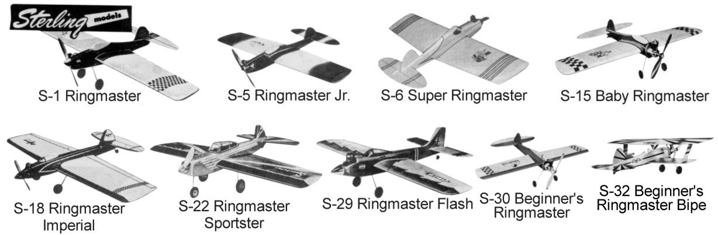
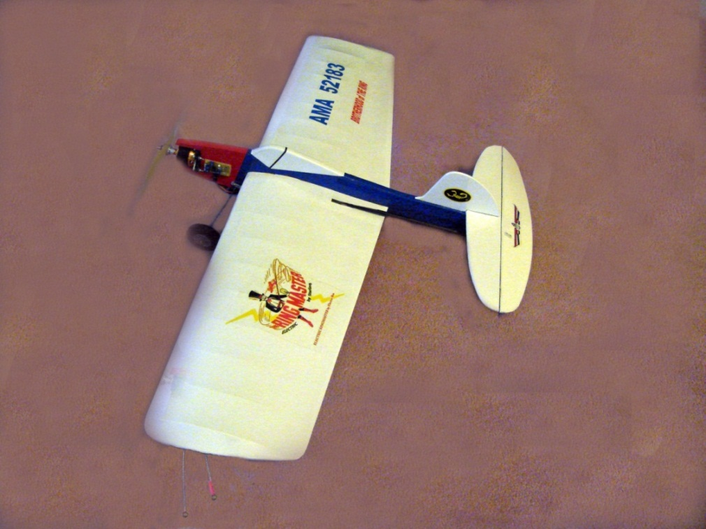
Numerous other variations have also been designed and built. Some of these are available as plans and others as plans and kits. All of these variations retain, for the most part, the original configuration of the S-1 Ringmaster. The Estes Company bought the Sterling Company rights and continued to produce and sell Ringmaster kits. After the Estes Company stopped producing Ringmaster kits, the RSM Distribution Company (Company (www.rsmdistribution.com) developed a Ringmaster S-1 kit with some internal design modifications and plans by Pat Johnston. This model is legal to fly “Old Time Stunt” contests using Pampa rules. RSM also has a kit available for the Super Ringmaster. The RSM kits can be purchased from a number of US mail order model suppliers.

Figure 2. The Author's Electric RSM S-1 Ringmaster

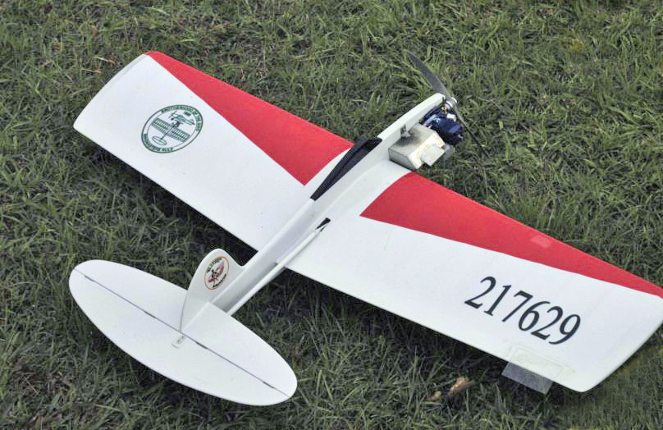

Figure 3 A good Example of an S-1 Ringmaster by Allan Hollier

Here is a list of kits produced by the Sterling and Estes Companies:
Sterling Ringmaster Kits:

- S-1 Ringmaster
- S-1A Ringmaster
- S-5 Ringmaster Jr.
- S-5a Ringmaster Jr. (sheet leading edge wing)
- S-6 Super Ringmaster
- S-15 Baby Ringmaster
- S-18 Ringmaster Imperial
- S-22 Ringmaster Sportster
- S-26 Custom Ringmaster
- S-29 Ringmaster Flash
- S-30 Beginner’s Ringmaster
- S-32 Beginner’s Ringmaster Bipe
- FS-40 Ringmaster RC
- FS-41 Ringmaster RC ARF

Estes Ringmaster Kits:

- STE6700 Ringmaster, (=S-1)
- STE6701 Ringmaster, (=S-1A)
- STE6750 Stuntin’ Ringmaster Pro
- STE6751 Stuntin’ Ringmaster Jr.
- STE6752 Lil’ Stuntin Ringmaster
- STE6753 PT Ringmaster

- STE6754 PT Ringmaster Bipe
More kits of the S-1 and S-1A Ringmaster models have been sold than any other control line profile model!!
Modern variations of the Ringmaster include:

- Pat King’s Ringmaster 150 (50 square inch wing area)
- Pat King’s Micro Ringmaster
- Pat King’s Micro ringmaster Bipe
- Pat King’s Ringmaster Bipe
- Pat Johnston’s Ringmaster 207
- Pat Johnston’s Ringmaster 526
- Pat Johnston’s Ringmaster 576
- Pat Johnston’s Ringmaster 1000
- Yvon Tarre’s Full Bodied Ringmaster 576
- Pat Johnston’s Ringmaster Deluxe
- Pat Johnston’s Super Duper Ringmaster
- John McCollum’s Ringmaster Twin
- Larry Marx’s Stagger Wing Ringmaster Bipe

Here are some examples of such variations:
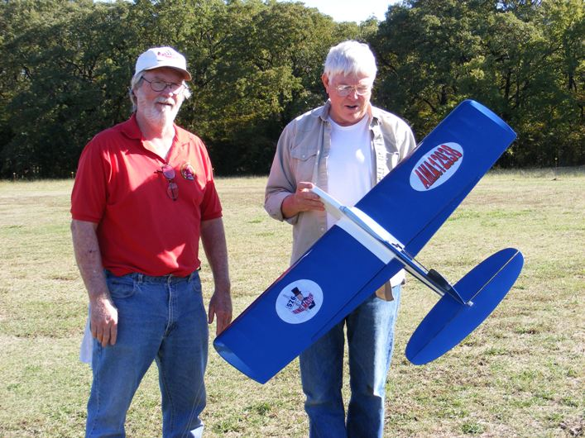
Figure 4. Richard Oliver and Dale Gleason with Dale's Ringmaster 576
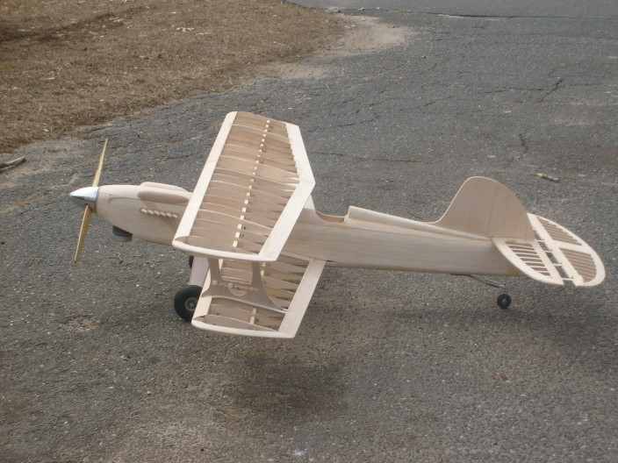
Figure 5. Bill (G-Man) Gruby’s 715 Ringmaster Bipe ready to cover
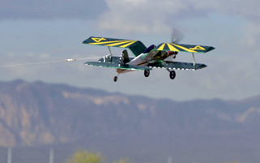
Figure 6. Larry Marx's Stagger Wing Ringmaster Bipe

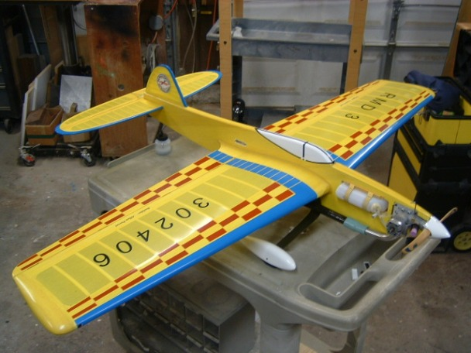
Figure 7. Allan Perret's Ringmaster Deluxe All Out Stunt Profile

The Ringmaster WEB Forum
In 2005 expert modeler Dee Rice from Houston, Texas, USA and fellow modeler David Gresens decided that the Ringmaster, which they had been flying in “Old Time Stunt” contests, deserved to have its own discussion forum on the World Wide Web. In January 2006 they started a Ringmaster forum which they called the Brotherhood of the Ring (www.brotherhoodofthering.info). This forum is devoted to Ringmaster models of all varieties whether they are old kitted models or modern versions created using the Ringmaster as a basic starting point. This forum has since grown to:
32 total forums
3472+ total threads
40462+ total messages

The forum includes an Album section which has extensive building photos of a number of different Ringmasters. Forum threads include topics such as step by step instructions by expert builder machinist Bill Gruby for making a special wing building jig and a custom control line handle. Forum founder Dee Rice has a thread on how to make a light built-up leading edge for the S-1 Ringmaster wing which is still legal for “Old Time Stunt” contests in the US. Many threads on the forum discuss events, special builds of Ringmasters, and solutions to various questions that may arise in building, trimming and flying Ringmasters.

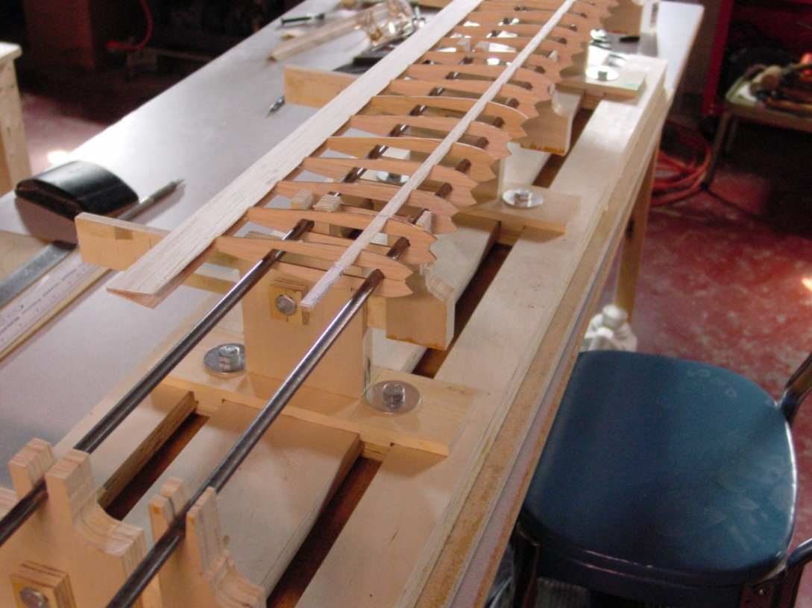
Figure 8. Ringmaster 207 Being Built on a Bill Gruby Style Jig

The Ringmaster Roundup
Dee Rice and David Gresens next collaborated to start a new S-1 Ringmaster only contest which was named the Ringmaster Roundup. The contest is held in Houston, Texas, each Spring. Only Ringmaster S-1 models can be used to compete in this contest but any variation of the Ringmaster can be flown for demonstration and for fun. Also any variety of the Ringmaster can be flown in a balloon bust competition.
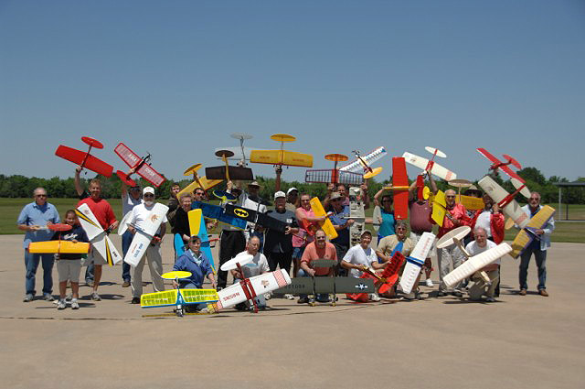
Figure 9. Photo Taken at Annual Ringmaster Roundup 2008. Yes They Are All Ringmasters
Contestants travel from great distances to attend these events. This year (2010) Yvon Tarre, a former French Navy pilot, traveled from France bringing a beautiful "take apart" Ringmaster variant. The model would fit in a specially built “carryon luggage” box to transport it in an airplane cabin while flying to Houston for the contest.
The Roundup contest consists of “Old Time Stunt” and Pampa stunt: Beginner, Intermediate, Advanced and Expert divisions. These events are held on Saturday. On Sunday, a special “Team Stunt” event is held. The Team Stunt event consists of teams of four or five fliers, each of whom fly in one of four events. The events are Old Time Stunt, Pampa Stunt, Unknown Stunt and Pursuit Combat. Unknown Stunt is an event where each flier is handed a list of maneuvers to be performed in the sequence listed. These maneuvers can be strange, such as three leaf clovers or a triangle with the apex down rather than up. The Pursuit Combat consists of two Ringmasters with streamers flying simultaneously. One Ringmaster is designated as the “Drone” and can only fly straight and level, while the other Ringmaster is the Pursuit plane and it attempts cut the streamer from the Drone. The Pursuit plane may also cut its own streamer by dropping down in front of the Drone but the Drone cannot maneuver to assist such a cut. Not all Pursuits end well!!!
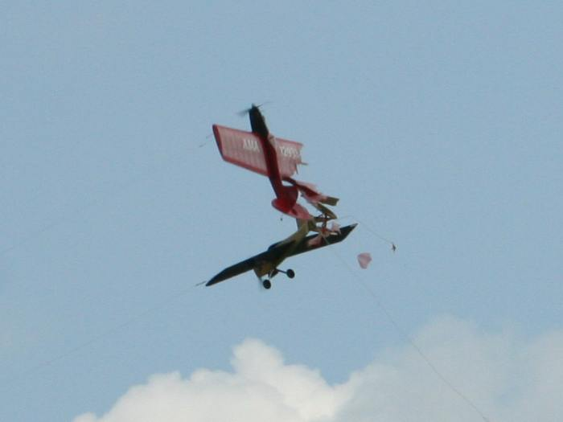
Figure 10. OOPS!!!!
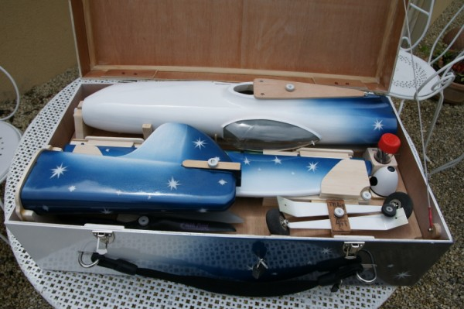
Figure 11. Yvon Tarre's Ringmaster 576 In Carry-on Luggage Box
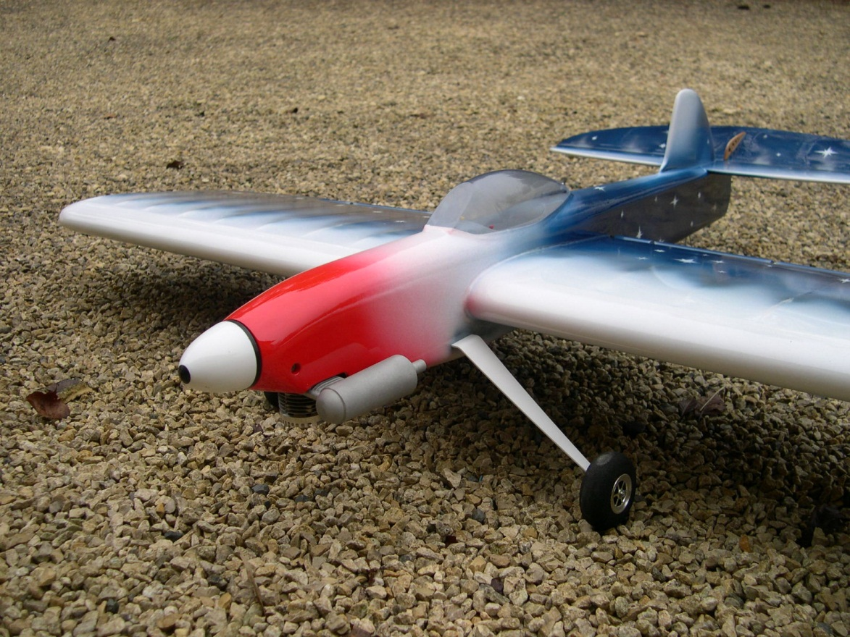
Figure 12. Yvon Tarre's Take-apart 576 Ringmaster Assembled
The Ringmaster Fly-A-Thon
In 2008 Mr. Joey Mathison from Las Vegas, Nevada, suggested that a weekend in the fall be designated for a "Ringmaster Fly-A-Thon." The event would allow any variety of the Ringmaster to be flown. The flights could take place anywhere in the world and the number of flights at each location would be submitted for tabulation to a central site by email. The total number of flights would be recorded and posted on the internet. This event would be coordinated by the Brotherhood of the Ring forum.
That year the first weekend in October was selected for the Fly-A-Thon and a total of 255 flights were recorded. It was decided that the Fly-A-Thon should be an annual event.
In 2009 The Ringmaster Fly-A-Thon recorded 288 flights. It was decided that the Fly-A-Thon was not only fun but was also a good way to promote control line modeling! Therefore, I was asked to try to really make the control line modelers worldwide aware of the event and to encourage participation. I was pleased to help and the result of this year’s Fly-A-Thon was outstanding!
With the help of participants from all over the world and an especially enthusiastic group in Alameda, California, USA that put up 432 flights, the Fly-A-Thon went over the top in participation and we recorded a record 887 Ringmaster flights!!
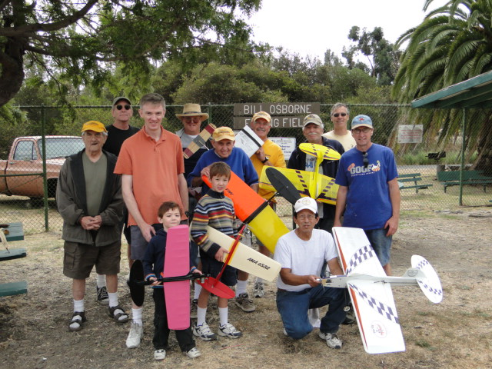
Figure 13. California Group That Made 432 Ringmaster Flights In The 3rd Ringmaster Fly-A-Thon
Our goal next year is to have over one thousand Ringmaster flights in the 4th Annual Worldwide Ringmaster Fly-A-Thon. The event is scheduled for the weekend of October 1-2, 2011, and we invite you all to participate!
The Ringmaster and its variants are wonderful planes to build and fly. The modern versions are quite competitive in control line stunt contests. Free plans are available for Pat King’s Baby Ringmaster and his Ringmaster Bipe. Also Gabriele Macri has drawn a nice set of plans for the original S-1 Ringmaster which are also free but in Italian and with metric measurements. There are also kits and plans available from Pat King (patdk@aol.com) and from Pat Johnston (patsplans@yahoo.com).
Here is a challenge!
Can you, the control line model fliers in club or area, put up a combined total of more than 432 Ringmaster flights in the 4th Annual Ringmaster Fly-A-Thon???
Good Luck and Have Fun!!!!

