Ringmaster Fly-A-Thon 2024
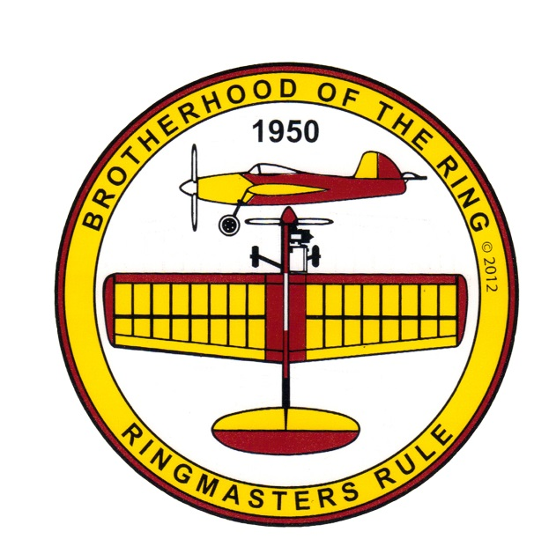
The Brotherhood of the Ring is sponsoring its 17th Annual Fly-A-Thon event:
October 5th & 6th, 2024
Matt Kania’s beloved Ringmaster control line model has been built and flown by more modelers than any other control line model airplane!
This is not a contest! No registration is required. There are no entry fees or prizes! This Fly-A-Thon is to honor the most popular CL model ever!! Be part of something really big and help make history by having more worldwide Ringmaster flights in a single weekend than our last year total of 612 Pilots & 7,581 flights from 2023!
Our Goal this year is 8,500+ flights by 700+ pilots! Our Ultimate goal is break the record 10,481!
This event is open to all participants worldwide!
On October 5th & 6th, we challenge you to fly any one or more of the many varieties of Ringmasters, old or new, and report your flights to: www.ringmasterflyathon.com
Deadline for reporting is 12:00 noon Eastern time (USA) Tuesday October 17th
Location: Wherever you are in the world!
Any Ringmaster from 1/2A to Giant and all variants in between can be flown.
Please report, how many total Ringmaster flights were made, how many different pilots flew, how many different Ringmasters flew and the location of these flights. Please feel free to include a lot of details of your event as we plan to chronicle the Fly-A-Thon for future publication!!! If you get a new pilot to solo on a Ringmaster, that first flight will count as 2 flights!
** A minimum of 5 laps & full stop after landing is required to count as an official flight! **

Let's keep the spirit of C/L alive!

Ok everyone! Just dig that old dusty Ringmaster from your attic and go fly it!
The results will be compiled and published by the Brotherhood of the Ring.
All questions should be directed to the primary contact: 2024flyathon@ringmasterflyathon.com
Rain/Wind/Flood/Conflict/etc. makeup weekend is October 12th and 13th

